CURRICULUM VITAE
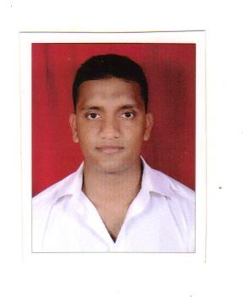
MADHUKARA SHETTY
Mobile. No: +91 9844709722
E-Mail ID: madhushetty015@gmail.com
Address
Kirinchabettu House , Ninjoor.
Ninjoor Post & Village
Karkala Taluk
Udupi Dist:-574244, Karnataka, India

PROFESSIONAL ASPIRATION

- To get a job in highly professional organization with challenging & competitive environment when I can use my knowledge base as well as personal attributes to achieve organizational goal.

Career Experience (4 years):-
- May-2011 to June-2012 Worked as a Roust About at Ankaleshwar Project, Gujarat, Shiv-Vani Oil & Gas Exploration Services Ltd- 2000 HP-ZJ70-D, Chinese Deep Drilling Rig.
- July-2012 to May-2015 Worked as a Floor Man at Karaikal Project, Tamil Nadu, Shiv-Vani Oil & Gas Exploration Services Ltd. – 2000 HP-ZJ70-D, Chinese Deep Drilling Rig.
Designation: Floor Man
Job Profile:-
- Follow the Driller Instruction.
- Job on Rig Floor During Drilling ,Tripping ,Coring, Casing Etc .
- Changing Mud Pump Liner, Piston, Fluid Ends.
- Changing the shale Shaker Screens.
- Casing Pipe Measurements, cleaning of threads, greasing and Gogazing Before fitting Float shoe .
- Worked on derrick During Tripping.
- BOP stack fitting during various Phase of Drilling and good knowledge of Gasket rings used in BOP stack fitting.
- Lineup of choke manifold ,H manifold ,Gas booster etc.
- Have worked in five Rig building operation.
- Laying of BOP control lines.
- Maintenance of all rig equipments.
- Having good knowledge in mechanical equipment
- Check For Emergency & Safety Equipment on Floor Such as FOSV, Grave Valve, etc.
- Crane signal.
EDUCATIONAL ATTAINMENT

- Bachelor Of Business Management (B.B.M)
Mangalore University.
M.S.R.S.College, Shirva
- IInd Puc. Commerce
Pre-University Board, Bangalore, Karnataka
Govt. Pu College, Bailur
- S.S.L.S Karnataka Secondary Examination Board, Bangalore,
Karnataka, Govt. High School, Palli
SAFETY COURSES

- Emergency Management
Ministry of Micro Small and Medium Enterprises
Govt. of India.
- STCW Courses:-

- Fire Prevention and Fire Fighting
- Personal Safety and Social Responsibilities
- Elementary First Aid
OTHER QUALIFICATION
Computer skill: Basic computer skills, MS-Word, Excel, Internet.

PERSONAL DETAILS

Date of Birth : 10th July 1990
Place of Birth : Ninjoor
Nationality : Indian
Pass Port No : K9841683
Place Of Issue : Bangalore
Date Of Issue : 12/03/2013
Date Of Expiry : 11/03/2023
INDos No : 12HL2825
Sex : Male
Civil Status : Single
Height : 5’10”
Language Known : English, Hindi, Kannada.
DECLARATION:
I do hereby declare that all the particulars stated here are true to the best of my knowledge.

Place :Udupi,Karnatakaa Yours faithfully,
Madhukara Shetty

